**Salazar Denver T.**

**IT SM 3101**

**SYSTEM ADMINISTRATION AND MAINTENANCE**

**Network Topologies**

**Mesh Topology**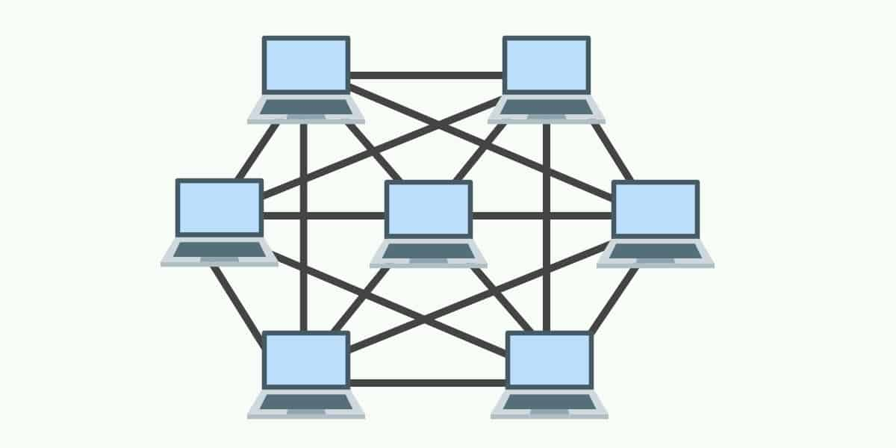

In Mesh Topology, every device is interconnected with every other device through dedicated channels or links. This setup ensures high redundancy and reliability, as multiple paths exist between devices. Common protocols for Mesh Topology include AHCP (Ad Hoc Configuration Protocol) and DHCP (Dynamic Host Configuration Protocol).

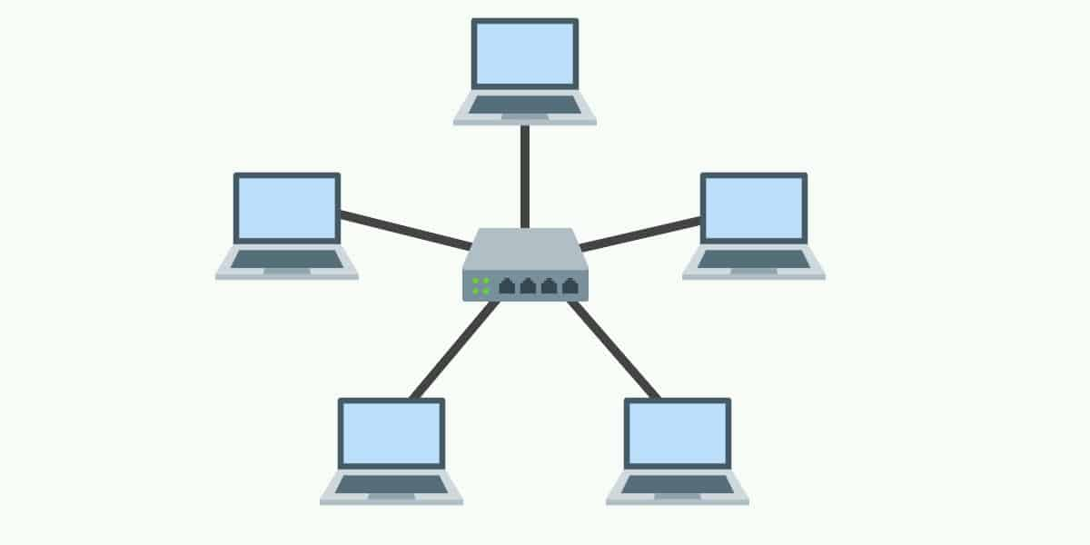

**Star Topology**

In Star Topology, all devices connect to a central hub via individual cables. This hub acts as the main node, with other devices communicating through it. The hub can be passive, serving only as a connector, or active, where it amplifies signals as a repeater to ensure robust communication.

**Point-to-Point Topology**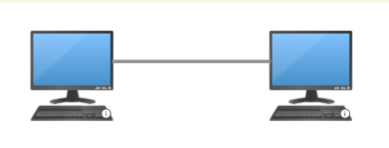

Point-to-Point Topology is a type of topology that operates on the principle of direct communication between two nodes. In this setup, one node acts as the sender and the other as the receiver, facilitating a simple and direct data transfer.

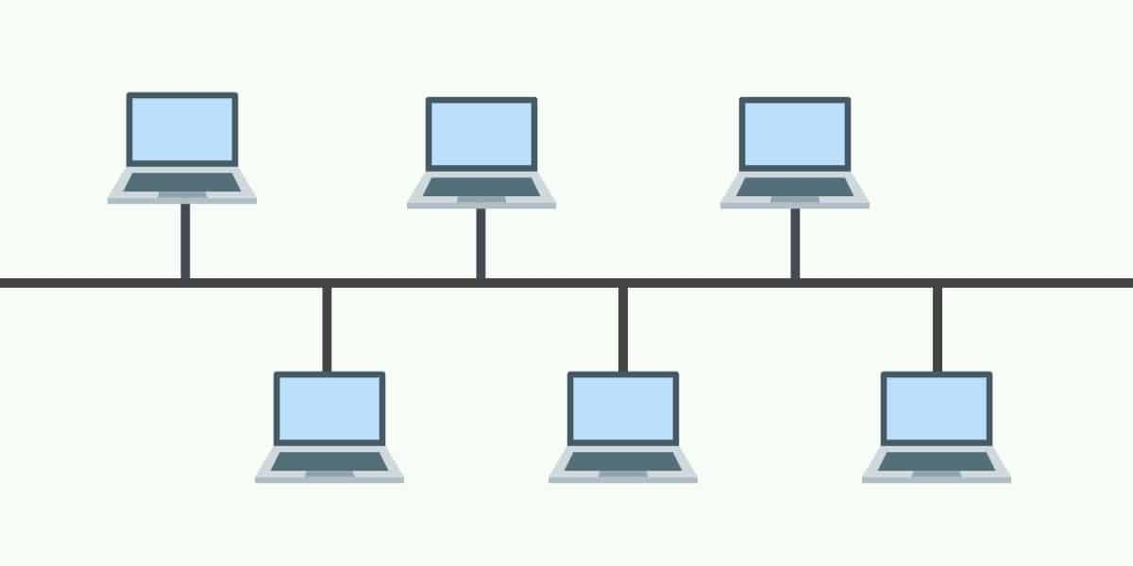

**Bus Topology**

Bus Topology features a single main cable that connects all devices. This cable acts as a backbone, allowing data to flow bi-directionally. However, a failure in the main cable results in a complete network outage, making this topology less robust.

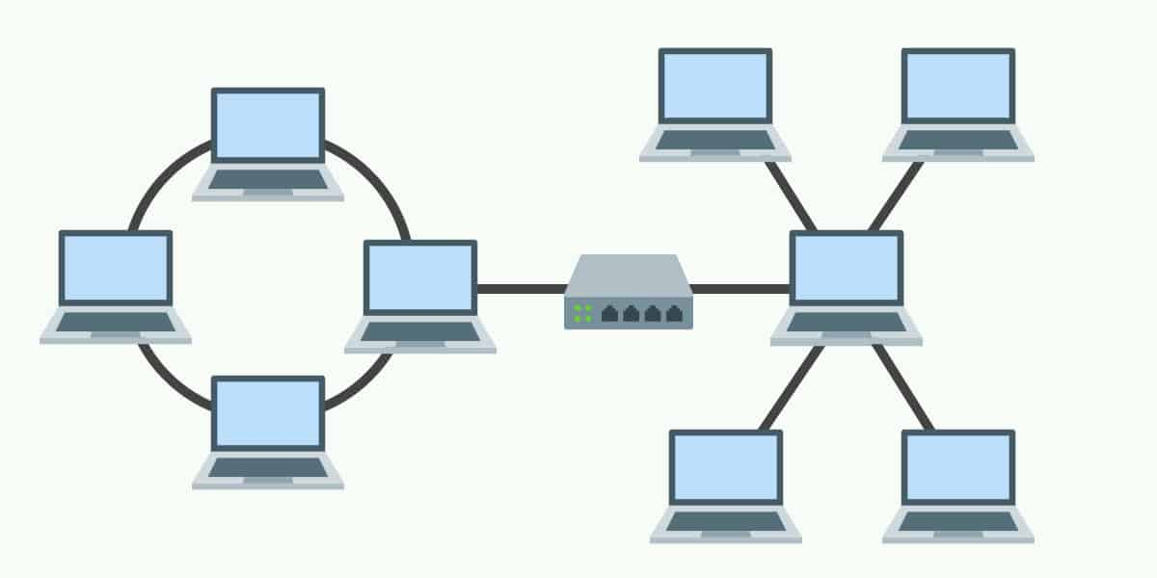

**Hybrid Topology**

Hybrid Topology combines various types of topologies, like Bus and Star, into a single network setup. It offers flexibility, allowing each node or segment to adopt a structure based on specific needs.

**Network Mediums**

**Wired Mediums**

* **Twisted Pair (TP)**: Often used in Local Area Networks (LANs) to connect devices, enabling internet access, file sharing, and communication. It provides a cost-effective and reliable connection.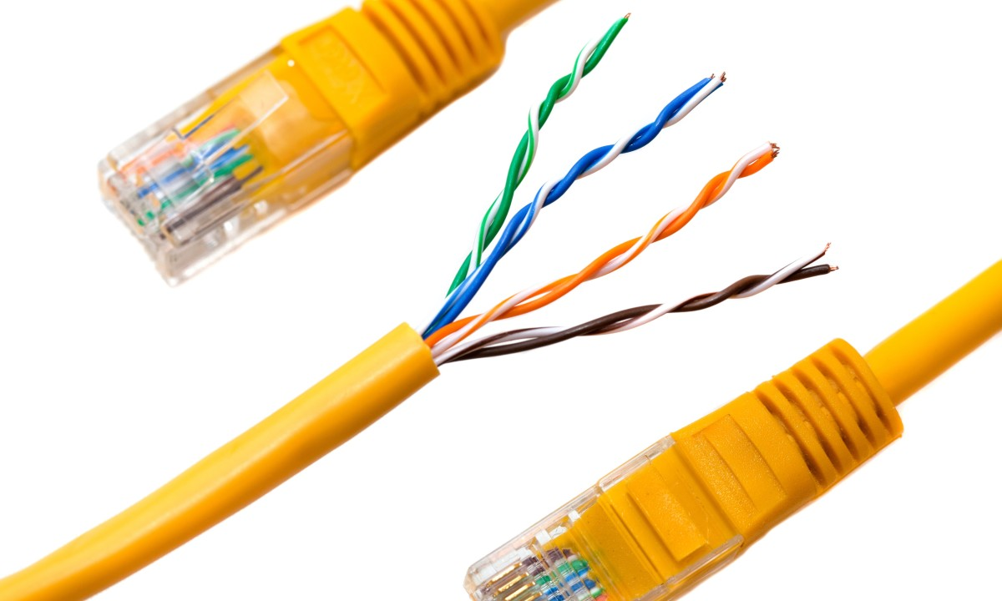
* **Coaxial Cable**: Commonly used for high-speed internet, cable television, and data services. Its shielded design makes it suitable for both residential and business applications.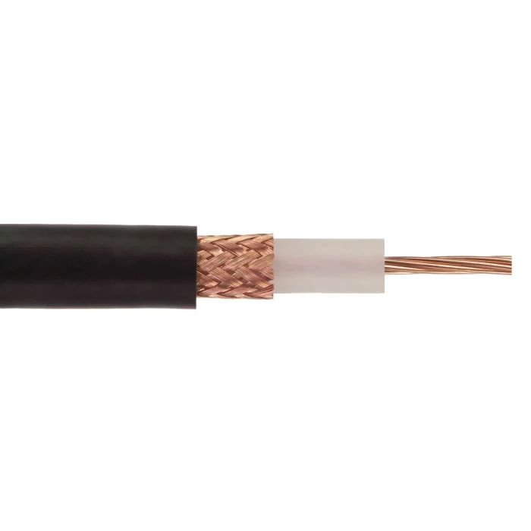
* **Ethernet**: A standard medium for connecting devices to LANs, typically seen in office and home networks, providing a secure and stable internet connection.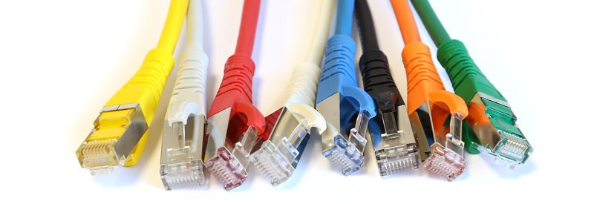
* **Powerline Communication (PLC)**: Allows data transmission through electrical wiring, making it suitable for smart homes and IoT devices without additional cabling.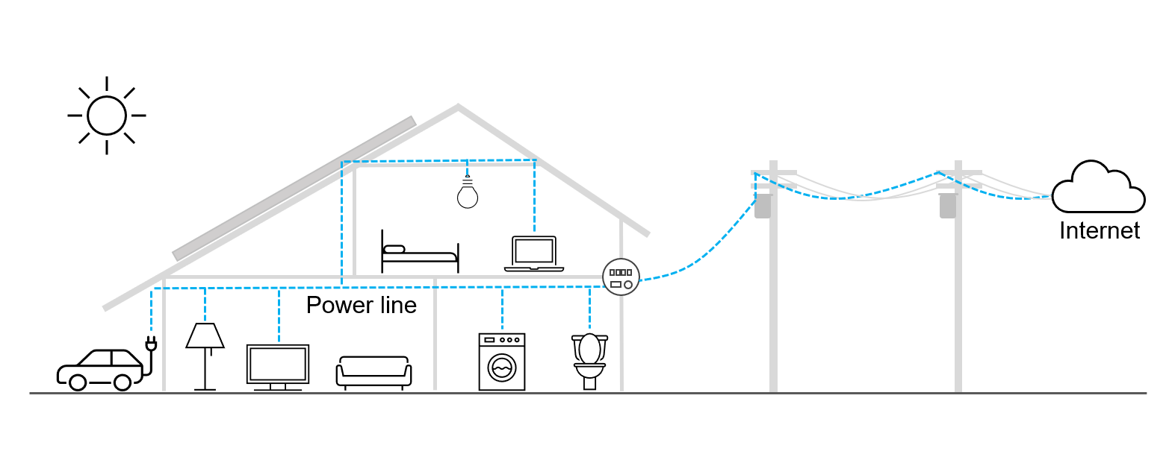
* **Fiber Optic**: Known for its high-speed data transmission capabilities, fiber optic cables are ideal for applications like data centers, cloud computing, and high-bandwidth online activities.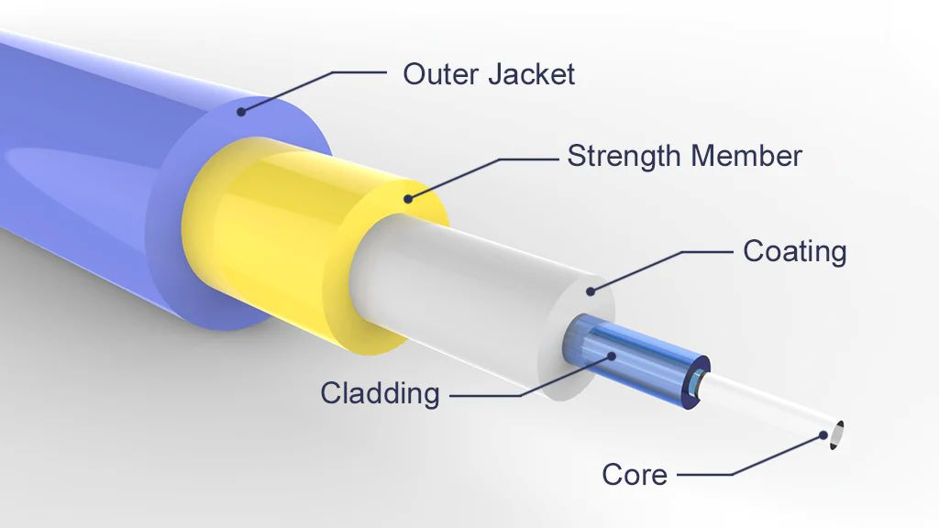

**Wireless Mediums**

* **Satellite**: Provides global internet access, GPS services, weather updates, and communication across vast distances, making it invaluable for remote and inaccessible locations.
* **Li-Fi (Light Fidelity)**: Utilizes light waves for high-speed wireless internet, offering enhanced security for sensitive data and applications.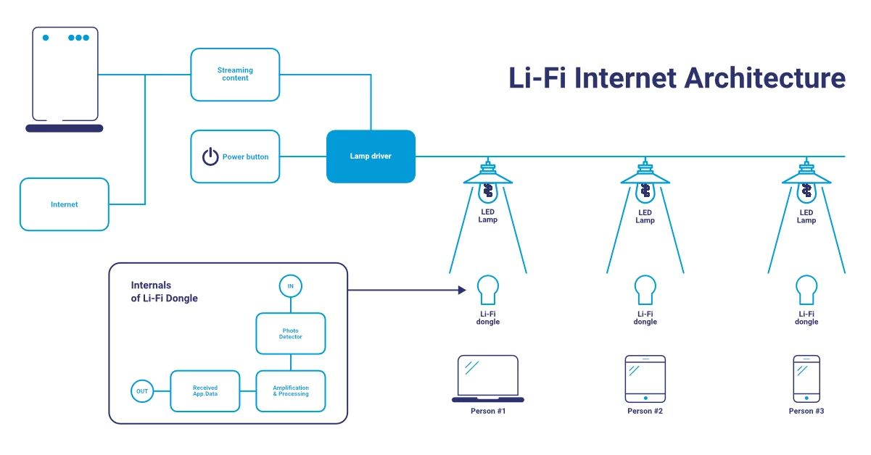
* **Infrared (IR)**: Facilitates short-range data transfers, commonly used in remote controls and certain types of wireless peripherals.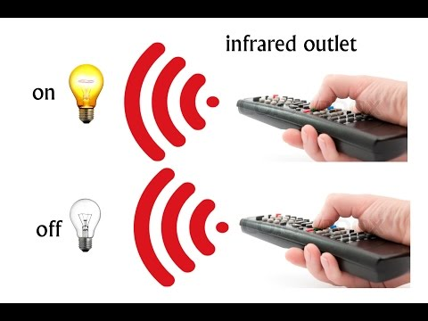
* **Radio Waves (Wi-Fi, Bluetooth)**: Enable wireless connectivity for internet access, file sharing, and device communication. Wi-Fi and Bluetooth are prevalent in personal and professional settings.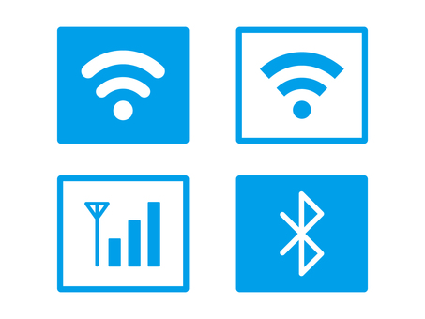

* **Microwaves**: Used in satellite and radar communications, as well as in Wireless Local Area Networks (WLANs). Microwaves enable long-distance wireless data transfer.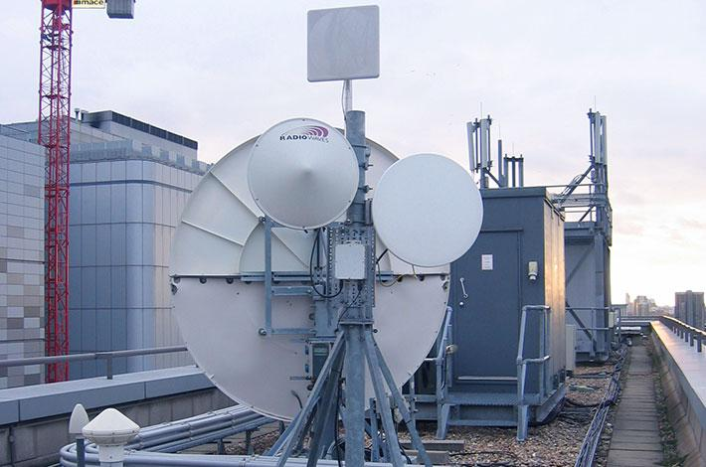

**Optical Mediums**

* **Optical Fiber**: Transmits data as light signals, enabling ultra-high-speed internet and data transmission. It is widely used in telecommunications and data centers.
* **Free Space Optics (FSO)**: Provides wireless optical communication for short distances, often used in last-mile connectivity solutions where physical cabling is impractical.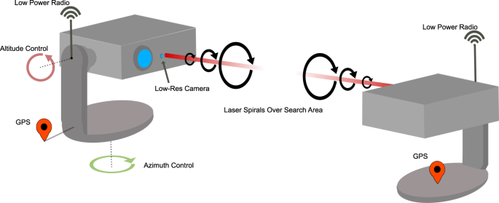

**Other Mediums**

* **Cable Modem**: Delivers internet access through cable TV networks, a popular broadband choice for residential users.
* **DSL (Digital Subscriber Line)**: Uses existing telephone lines to provide internet access, commonly adopted for home internet users due to its affordability.
* **Dial-up**: An older form of internet connection via phone lines, still used in some areas with limited broadband availability.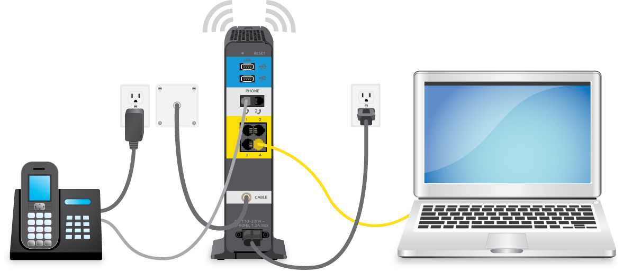
* **Leased Lines**: Offer dedicated, high-speed internet connections for businesses, providing secure and reliable connectivity.